**COMMUNITY SERVICE PROJECT REPORT**

*on*

# TIMBAKTU-A PIONEERING NGO

Under the guidance of

## Prof.B.ESWARA REDDY

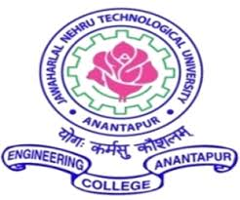

**Department of Computer Science and Engineering**

**JNTUA College of Engineering**

**Ananthapuramu**

**Andhra Pradesh**

**2025-26**

## 

## 

## JNTUA COLLEGE OF ENGINEERING

## ANANTAPURAMU, ANDHRA PRADESH, INDIA

**2025-26**

**DEPARTMENT OF**

**COMPUTER SCIENCE AND ENGINNERI**



**CERTIFICATE**

This is to certify that the community project titled ”TIMBAKTU-A PIONEERING NGO” submitted to Department of Computer Science and Engineering, JNTUA College of Engineering is a Bonafide record of work done under my supervision.

B.Raja Vardhan 23001A0505 N.V.Krishna Reddy 23001A0539

A.Murali Mohan 23001A0513 N.Karthik Reddy 23001A0542

K.R.Harsha Vardhan 23001A0523 M.Rana Sadiq 23001A0554

**Signature of Guide Signature of HOD**

**B.Eswara Reddy Dr.K.F.Bharati**

Professor, Associate Professor & HOD,

Computer Science and Engineering, Computer Science and Engineering,

J.N.T.U.A.College of Engineering, J.N.T.U.A.College of Engineering,

Ananthapuramu – 515002. Ananthapuramu – 515002.

## DECLARATION

We, hereby declare that this Community Service Project report titled ”TIMBAKTU-A PIONEERING NGO” has written by us. The work carried out is original and has not been submitted to any other University or Institution for the award of any credits.

B.Raja Vardhan 23001A0505

A.Murali Mohan 23001A0513

K.R.Harsha Vardhan 23001A0523

N.V Krishna Reddy 23001A0539

N.Karthik Kumar Reddy 23001A0542

M.Rana Sadiq 23001A0554

Place: Anantapuramu

Date:

**ACKNOWLEDGEMENT**

The satisfaction and euphoria that accompany the successful completion of any task would be incomplete without the mention of people who made it possible, whose constant guidance and encouragement crowned our efforts with success. It is a pleasant aspect that we have now the opportunity to express my gratitude for all of them.

It is with immense pleasure that we would like to express my indebted gratitude to our Guide **Prof.B.Eswara Reddy** Professor of Computer Science and Engineering Department, who has guided me a lot and encouraged me in every step of the project work. We thank him for the stimulating guidance, constant encouragement and constructive criticism which have made possible to bring out this project work.

We are very much thankful to **Dr.K.F.Bharati** Associate Professor & HOD of Computer Science and Engineering Department for his kind support and for providing necessary facilities to carry out the work.We wish to convey my special thanks to our principal **Prof.P.Chenna Reddy**, Principal of Jawaharlal Nehru Technological University Anantapur college of Engineering Anantapuramu for giving the required information in doing my project work. Not to forget, we thank all other faculty and non-teaching staff, and my friends who had directly or indirectly helped and supported me in completing my project in time.

|  |  |  |
| --- | --- | --- |
| **S.NO** | **LIST OF CONTENTS** | **PAGE NO.** |
| 1 | Introduction | 1 |
| 2 | Objectives and Methodology | 2 - 10 |
| 2.1 | Goals | 2 |
| 2.2 | Procedure & Weekly Reports | 3 - 10 |
| 3 | Problems and Solutions | 11 - 15 |
| 3.1 | Challenges | 11 |
| 3.2 & 3.3 | Experiences and Photographs | 12 - 15 |
| 4 | Benefits | 16 |
| 5 | Conclusion and References | 17 - 19 |
| 5.1 | Conclusion | 17 |
| 5.2 | Inferences | 18 |
| 5.3 | References | 19 |

**PREFACE**

The Timbaktu Collective is a registered non-profit organization based in Anantapur district, in the state of Andhra Pradesh, India. It was founded in 1990 by Bablu Ganguly, Mary Vattamattam, and a few like-minded activists who were inspired by Gandhian and ecological values. They left urban lives to settle in a degraded, drought-prone region in order to work with marginalized rural communities and promote sustainable, self-reliant development.

The word “Timbaktu” was chosen symbolically—it refers to a once barren piece of land in the region where the founders began their work, slowly regenerating it into a thriving forest and community space. Over time, Timbaktu became a living example of ecological restoration, community ownership, and local empowerment.

The Collective focuses on working with landless laborers, small and marginal farmers, women, children, persons with disabilities, and Dalit communities. It aims to revitalize rural economies and ecosystems while ensuring equity, justice, and sustainability.

Key initiatives include:

* **🌾 Dharani**: Supports small farmers to adopt organic methods and market their produce collectively, ensuring fair prices and sustainable practices.
* **🌱 Kalpavalli**: A community-led ecological restoration initiative that regenerates thousands of acres of dry forest and degraded lands through afforestation and conservation.
* **👩‍👧 Swasakthi**: Women’s empowerment through Self-Help Groups (SHGs), promoting financial literacy, savings, credit access, and leadership.
* **👧 Chiguru**: An alternative education program for children, focusing on child rights, joyful learning, and inclusive education methods.
* **♿ Militha**: Supports persons with disabilities to achieve independent and dignified lives through inclusion, training, and advocacy.

The Timbaktu Collective is now working with over 20,000 families in more than 200 villages across Anantapur district. It has received national and international recognition for its innovative work in natural farming, gender equality, child-friendly education, and community-driven conservation.

The Collective operates on the principle that real development happens when communities are involved in designing and managing their own futures. It blends traditional knowledge with modern tools and fosters local leadership to create lasting change from the ground up project.

**ABSTRACT**

This community service was undertaken in association with the **Timbaktu Collective**. A renowned non-profit organization based in Anantapur, Andhra Pradesh, committed to promoting sustainable rural development, ecological regeneration, and community empowerment. The seven-week-long project was structured to include both remote and on-field components, ensuring a holistic learning experience that combined theoretical understanding with practical engagement.

The first four weeks focused on remote learning, during which we studied the history, philosophy, and key initiatives of the Timbaktu Collective. Through website analysis, online articles, documentaries, and interviews with past volunteers, we explored the functioning of various programs such as Dharani (organic farming cooperative), Swasakthi (women empowerment through SHGs), Chiguru (alternative education), and Kalpavalli (ecological regeneration). These sessions helped us understand how the Collective integrates sustainability with community-driven development and values such as equity, participation, and dignity. We also used this time to develop communication strategies, create ethical data collection plans, and schedule field visits for June 17 and 18, in consultation with the organization.

The last three weeks comprised fieldwork, including site visits to farms, forests, learning centres, and self-help group meetings. We interacted directly with farmers, educators, SHG women, and ecological workers to understand the real-life impact of the Collective's efforts. We observed organic farming methods, forest conservation practices, women-led savings groups, and child-centred teaching methods in action. Each interaction enriched our understanding of grassroots transformation, and each observation reinforced the importance of decentralized and inclusive models of development.

Throughout the project, teamwork played a vital role. From digital coordination during the remote phase to mutual support during the physically demanding fieldwork, the spirit of collaboration helped us overcome challenges like network issues, weather constraints, and language barriers. Reflective journaling, group discussions, and report writing ensured continuous learning, self-evaluation, and skill development in communication, research, and ethics. This community service initiative not only deepened our understanding of sustainable development and social equity but also inspired us to think critically about the role of youth in community-building. Working with the Timbaktu Collective allowed us to witness first-hand how small, consistent efforts at the grassroots level can lead to powerful systemic change. It has reinforced our commitment to civic responsibility, environmental stewardship, and inclusive growth. We are grateful for this opportunity and hope to carry these learnings forward into our academic, professional, and personal journeys.

**CHAPTER 1**

**INTRODUCTION**

**1.1 ABOUT THE PROJECT**

**1.1.1 AREA OF WORK**

The Timbaktu Collective is a grassroots nonprofit organization based in Chennekothapalli village, Anantapur district

#### 1.1.2 GOAL

To support the Timbaktu Collective’s grassroots efforts in sustainable agriculture, education, women’s empowerment, and environmental conservation by field-based engagement— enhancing communication, documentation, and community participation while gaining practical exposure to rural development practices.

#### 1.1.3 PROJECT DESCRIPTION

The primary objective of the project was to understand the mission, structure, and impact of the Timbaktu Collective through observation, research, and participation. The organization works across key areas such as sustainable organic farming, children’s education and rights, women’s empowerment, and ecological restoration. During the remote phase, we focused on studying the organization’s background, exploring its official resources, watching related media, and discussing their model of rural development. In the field phase, we had the opportunity to visit project sites, interact with staff, observe ongoing programs, and engage with local communities.

**1.1.4 BENEFICIARIES**

The beneficiaries of this community service project with the Timbaktu Collective span across several segments of rural society. Small and marginal farmers benefit through their involvement in sustainable agricultural practices and organic farming promoted by the Dharani initiative, which also helps them access better markets and fair prices. Children from marginalized communities are supported through the Chiguru program, which provides inclusive, creative, and nurturing educational environments. Rural women organized into Self-Help Groups (SHGs) benefit through the Swasakthi and Sangham initiatives, which empower them economically and socially by improving access to credit, training, and leadership opportunities. Local communities living in eco-sensitive zones also benefit from conservation efforts under Kalpavalli, which focus on forest regeneration, biodiversity, and climate resilience. Additionally, the staff of the Timbaktu Collective benefits from the documentation and awareness support provided by volunteers. Finally, student volunteers like us benefit from the exposure to grassroots development, gaining practical insights, communication skills, and a deeper understanding of sustainable and community-driven change.

1

**CHAPTER 2**

### OBJECTIVES AND METHODOLOGY

#### 2.1 GOALS

To support the Timbaktu Collective’s efforts in promoting sustainable rural development through observation, participation, and basic digital support—while gaining practical knowledge about community-based approaches to ecological conservation, education, and empowerment.

The main objectives of our community service are:

1. To observe and understand the functioning of the Timbaktu Collective’s initiatives,

including Dharani, Chiguru, Swasakthi, and Kalpavalli.

1. To interact with the staff, volunteers, and community members involved in each initiative

to gain real-world insights into their challenges, strategies, and impact.

1. To explore how grassroots organizations promote sustainable development through

community participation, self-reliance, and ecological practices.

1. To document key learnings from each initiative through notes, interviews, photos, or

short videos, which can be used for reflection or reporting.

1. To understand the role of self-help groups, cooperatives, and education programs in the

empowering marginalized rural populations.

1. To reflect on how these community-driven models can inspire future projects or contribute

to our understanding of social responsibility and sustainability.

1. To learn how the Timbaktu Collective manages and sustains its long-term projects through

local leadership, decentralized planning, and inclusive decision-making.

1. To explore how traditional knowledge and local culture are integrated into the Collective’s

approach to education, farming, and environmental conservation.

1. To analyze the real-life impact of the Timbaktu Collective’s work on rural communities by

Listening to beneficiary stories and observing visible changes in livelihood, education,

and environment.

2

**2.2 PROCEDURE AND METHODOLOGY**

We followed some basic steps before getting into the actual community service. Firstly, we just did research and found out what is needed and required in our community. We had a discussion among ourselves, friends, and neighbors about this topic and decided the community we got to work on. Then we checked and sorted out what ability we have got i.e., about what we can do. We thought it would be better if we shared some the knowledge we have got to the young. And we checked on the time that is available to us and we checked how many hours per week can we devote to the project.

And the next thing we did is we choose the topics on which we could work on. We prepared a short documentation on the topics that we are going to teach about. We ranked the list from most to least important. We had a discussion among ourselves and assessed what makes more impact. Next thing we did is to develop a plan. To develop a schedule according to which we could work. We also went into the practicalities of the project. How much equipment will you need? How many people will you need to successfully complete each part of the project? How much time can each person commit to the project? How will you organize different volunteers? And we sorted the whole work according to these. We ensured that the project takes place safely and legally. Then we made a timeline to work. We made specific schedules for each of our volunteers based on how much time each can contribute.

After organizing all the equipment and schedule we require for the project, we started working on it. We visited the organization to take permissions and agreements from the manager and we discussed the purpose and need of our project with them. We had peaceful ties with them and they too encouraged us to go forth . We checked on the sites where there are initiatives which have to learn about. And we ensured feasibility so that we could adjust out time within the working hours of the organization.

As far as the method is concerned, we did it in a very friendly manner. We had one on one interactions with them and we had to push them to come forward to speak. They too were enthusiastic. And we were successful with the method we employed.

3

**WEEKLY REPORT**

|  |
| --- |
| **WEEK-1** |
| We opened the project by devoting ourselves entirely to understanding why the Timbaktu Collective exists. Every morning began with individual reading of the organization’s foundational documents, including its registration papers, early newsletters,paper, anniversary reflections.  We studied the socio‑ecological profile of Anantapur district, mapping rainfall patterns, land‑use changes, and poverty indices to appreciate the environmental stress that originally inspired the founders.Peer discussions in the afternoon helped us compare the Collective’s grassroots ideology with top‑down rural‑development paradigms we had encountered in textbooks.  We summarised our insights on a shared digital whiteboard, identifying four keywords equity, ecology, participation, dignity—that appear consistently in Timbaktu’s communications.Late in the week, we held a remote call with an alumnus volunteer who described the joy and complexity of working in a dryland landscape and also how their day will be at the end they reach. That conversation grounded our theoretical learning in lived experience and underscored.By Friday, we could articulate how the Collective’s approach differs from conventional NGO service delivery: it sees communities not as beneficiariesThe week closed with a virtual group circle where we shared one word that captured our feeling—many chose “grounded,” “inspired,” or “challenged.”  Overall, Week 1 laid a philosophical foundation, clarifying the why behind the project before we moved on to the how. It also taught us the discipline of daily reflection—a habit that would prove invaluable during the intense field phase. We recognised that true understanding demands both intellectual rigour and emotional openness, a balance we resolved to maintain. Thus, the week ended not with answers but with deeper, better questions. |

**Signature of Mentor**

4

**WEEKLY REPORT**

|  |
| --- |
| **WEEK-2** |

|  |
| --- |
| The second week shifted our focus from philosophy to program architecture, unpacking how different initiatives translate core values into daily practice and our daily life scenes. We began with **Dharani**, reading case studies about how smallholders transition from chemical to organic farming under a cooperative umbrella.Next, we examined **Chiguru**, downloading annual reports and lesson‑plan samples that revealed an emphasis on experiential, multilingual learning. A recorded webinar featuring Chiguru facilitators highlighted the importance of play, storytelling, and access to nature in child development.We then turned to **Swasakthi** and its sister network **Sangham**, charting their evolution from micro‑credit groups to platforms. Gender‑audit worksheets enabled us to assess how decision‑making power shifts when women control savings and loans.Late in the week, we explored **Kalpavalli**, virtually touring before‑and‑after satellite images that showed remarkable vegetation recovery over two decades. We also read wildlife‑survey summaries citing the return of Indian grey wolves and sloth bears, linking biodiversity gains to community stewardship.We noticed, for example, that women trained in Swasakthi often champion organic practices at home, while children involved in Chiguru carry conservation messages to their families.By week’s end, we felt confident naming program specifics, yet we also acknowledged gaps that only on‑site observation could fill. Hence, we updated our question bank, inserting queries about cooperative governance.  Week 2 thus transformed abstract program names into vivid, interconnected systems of change ready to be explored first‑hand and curiosity to know something in the wondering journey. It reaffirmed that sustainable development is multi‑dimensional, requiring simultaneous attention to livelihoods, learning, gender equity, and ecology. |

**Signature of Mentor**

5

**WEEKLY REPORT**

|  |
| --- |
| **WEEK-3** |
| Week 3 served as the bridge between digital preparation and physical immersion. We opened with a workshop on professional email etiquette, after which we drafted a concise yet appreciative introduction to the Timbaktu administration office and the people we met. Within 48 hours, we received confirmation that **visitor interaction days would be 17 and 18 June**, along with guidelines on respectful conduct and photographic consent.We mapped travel routes from our campus to Chennekothapalli village, comparing overnight trains with early‑morning buses to evaluate cost, safety, and buffer time.  A medical volunteer briefed us on hydration practices, heatstroke symptoms, and the importance of carrying oral rehydration salts and water,snacks during June’s intense heat. We finalised a field checklist covering IDs, notebooks, power banks, reusable bottles, locally appropriate clothing, translation aids, and small tokens of gratitude for interviewees. To build cultural sensitivity.  we practised basic Telugu greetings and learnt key agricultural terms such as “pachha jaathi”  Mid‑week, we held a role‑play exercise simulating conversations with farmers, educators, and SHG leaders, which highlighted the need to frame and design open‑ended questions. We also prepared an ethics charter outlining respect for privacy, non‑extraction of data, and the responsibility to share findings back with the community and share them too. Daily debriefs captured logistical uncertainties—ranging from phone‑network reliability to availability of vegetarian meals—so contingency plans could be drafted. The team allocated specific roles: two members for note‑taking, one for photography, one for translation support, and one for time‑keeping.It underscored that successful field engagement hinges on respectful communication, thorough planning, and cultural humility. By Saturday evening, excitement and jitters co‑existed, but we felt synchronised as a team and eager to apply classroom knowledge in the living laboratory of Timbaktu. Thus ended the remote phase, leaving us poised on the threshold of experiential learning that would test improve and make us very perfect to enrich and also to grow our understanding. |

**Signature of Mentor**

6

**WEEKLY REPORT**

|  |
| --- |
| **WEEK-4** |
| Although travel would not begin until Week 5, Week 4 offered a breathing space to consolidate knowledge and refine intentions. We revisited our mind maps, adding fresh insights gleaned from conversations with alumni volunteers who emphasised the unpredictability of rural schedules. Everyone updated individual learning sheets, ranking their top three inquiry areas—mine were cooperative governance, child-centred pedagogy, and participatory forest management. Morning sessions were devoted to reading “The Timbaktu Way,” a compendium of essays that delve into the Collective’s philosophical moorings in Gandhian and ecological thought. Afternoons featured reflective writing: we penned letters to our future selves, articulating what we hoped to learn and how we wished to behave in the field. Those letters were sealed and would be opened after the visit to assess personal growth. We also conducted a peer review of our question bank, removing any queries that could appear intrusive or disrespectful.  All the days culminated in a round-table reflection led by Prof. Eswara Reddy, who challenged us to think about the difference between observation, participation, and intervention.His probing questions nudged us to be conscious of power dynamics and to practise reflexivity. Sunday carried a quiet excitement; luggage stood ready, minds were focused, and the values we had studied felt alive and urgent.Even though we have some knowledge we thought about learning something new which could help us in the future. Week 4 thus served as both a knowledge-consolidation phase,Moreover it is exciting in that week and a moment of calm before the vibrant realities of fieldwork. It reinforced the principle that careful preparation is in itself a gesture of respect towards the communities we hoped to learn from. |

**Signature of Mentor**

7

**WEEKLY REPORT**

|  |
| --- |
| **WEEK-5** |
| Our first dawn in Chennekothapalli greeted us with an orchestration of koel calls and goat bells, instantly immersing us in rural area.We bounced along red‑earth tracks to reach a cluster of organic farms that supply produce to **Dharani**.We tasted sun‑dried groundnut directly from the field, the flavour surprisingly sweet compared to market varieties, confirming anecdotes about nutrient density.Conversations revealed economic benefits—reduced input costs and premium prices—but also challenges like pest outbreaks and certification paperwork.We observed cooperative meetings where price decisions were made collectively, underscoring democratic conversations in the acting where they said about the total procedure of the dharani.  Post‑lunch, we headed to **Kalpavalli**, where hills once barren now wore a mosaic of grasses, shrubs, and young trees.Short hikes allowed us to touch stone bunds directing rainwater, evidence of watershed management that curbs soil erosion and make the soil fertile and make nutrient-rich. Mid‑afternoon heat soared beyond 40 °C; hydration breaks reminded us of the harsh climatic context in which resilience is built.Despite fatigue, the landscape’s quiet grandeur fuelled our curiosity,raised questions about our lifestyle in cities and towns.Back at the guest hut, we debriefed for two hours, mapping insights onto our data‑collection template while memories were fresh.Evening reflections surfaced emotions—a mix of awe at nature’s recovery and respect for human perseverance.  Week 5, thus delivered a living lesson on the interdependence of soil health, biodiversity, and human well‑being.it validated every theoretical claim we had studied and left us eager to explore social dimensions the next day. |

**Signature of Mentor**

8

**WEEKLY REPORT**

|  |
| --- |
| **WEEK-6** |
| The second field day began with a visit to the Chiguru Learning Centre, where children’s laughter echoed across an open courtyard painted with bright murals.Staff explained their assessment method, which focuses on holistic growth indicators—confidence, creativity,character driven and most of the children are tried to be a person full of ethics,behaviour. Mid‑morning, we travelled to a nearby village to meet Swasakthi Self‑Help Group members gathered under a tamarind tree.The women proudly displayed their savings ledger, micro‑enterprise products, and a calendar of peer‑education sessions on health and nutrition. One member narrated her journey from silence in village meetings to confidently negotiating crop prices with traders, highlighting empowerment in action.Technical glitches and laughter co‑existed, revealing both the challenges and joy of technological inclusion.  We saw toddlers playing nearby, cared for by group members in rotation, a quiet but powerful. Late afternoon brought a community walk during which women pointed out solar‑street lights they had lobbied the panchayat to install and for to demonstrating civic engagement. Exhausted yet exhilarated, we returned to base and held a reflective dialogue on gender, power, and structural change.We compiled our photographs and anonymised quotes, ensuring ethical storage and future consent for any public presentation.Day 2 concluded with a realisation that human empowerment, like ecological restoration, thrives on collective processes grounded in localrealities.  The lessons were vivid, heartfelt, and likely to stay with us long after the project ends. Week 6, therefore, deepened our insight into the social fabric that sustains community transformation, complementing ecological insights from Day 1. |

**Signature of Mentor**

9

**WEEKLY REPORT**

|  |
| --- |
| **WEEK-7** |
| The final week began with a sense of completion yet also of new adventurous beginnings. We dedicated mornings to transcribing interview notes,tagging photos and extra things  Parallel to documentation, we conducted team debriefs where each member narrated their most challenging and their most uplifting moments in the whole travel we have done.. These story‑sharing circles not only strengthened group cohesion but also surfaced diverse perspectives that enriched our collective understanding.  Friday was devoted to final edits, referencing, and formatting our 20‑page report, ensuring it met institutional guidelines.We transcribed interviews, organized notes and photographs, and collaboratively reflected on our most meaningful insights. We wrote individual reflection essays capturing key takeaways, skills learned, and moments that challenged or inspired us. Our final group report was compiled, blending data with real human stories. We also created a presentation to share with our mentor summarizing our experiences and insights. Additionally, we held a gratitude circle to express appreciation for our teammates, guides, and the community members who shared their time with us. This final week reinforced the importance of community participation, teamwork, adaptability, and humility. It became evident that development is not just a technical or economic process but a deeply human one, rooted in relationships, trust, and sustained commitment. The combination of fieldwork and reflection gave us a complete picture—allowing us to witness transformation, process our learnings, and commit ourselves to responsible social engagement in the future. |

**Signature of Mentor**

10

**CHAPTER 3**

**PROBLEMS AND SOLUTIONS**

#### 3.1 PROBLEMS GIVEN BY EACH INITIATIVE

#### 

#### 3.1.1 PROBLEMS IN DHARANI

1.Dharani Cooperative faced challenges with basic and unattractive packaging, which affected both product appeal and buyer confidence. The lack of product transparency—like manufacturing and expiry dates, origin, or certification—made it harder to build trust with modern consumers.

2. Dharani mainly sells in niche or local markets. Their access to large cities, online platforms, and international markets is still limited..

**3.1.2 PROBLEMS IN CHIGURU**

1. Children involved in the Chiguru initiative, though creative and eager to learn, had minimal or no exposure to modern technologies such as computers, the internet, or digital tools. This technological gap limits their ability to keep up with the evolving education system and future employment opportunities.

2. Most children in Chiguru were unaware of the wide variety of career opportunities beyond traditional roles. Due to lack of guidance, exposure, or relatable role models, their dreams were confined to what they see around them—often limited to farming, basic labor, or local shop work.

**3.1.3 PROBLEMS IN KALPAVALLI**

1. Despite being protected, cattle from nearby villages are often sent into Kalpavalli for grazing. In some cases, people even try to cut down regenerating trees or clear patches for personal use. This disturbs the slow natural regeneration of the forest and damages fragile native species.

**3.1.4 PROBLEMS IN DOING ORGANIC FARMING**

1. Many farmers don’t use apps or tech tools that could make their farming smarter and more efficient. They also don’t know about many useful apps which are available and use them which make their organic practice very much better.

11

**3.1.5 PROBLEMS IN DOING GRAMASIRI**

1. The women and local youth involved in Gramasiri have limited exposure to digital tools or platforms to market their products.

2. Gramasiri sells in limited outlets — mainly fairs and a few partner stores.

**3.2 IDEAS GIVEN BY US TO PROBLEMS**

**3.2.1 IDEAS FOR DHARANI**

To address this, we gave an idea about smart QR code system that can be printed on each product’s packaging. When scanned, the QR provides essential batch-level information such as manufacturing date, expiry date, farmer group, and certification status. This low-cost digital upgrade improves product traceability, adds transparency, and enhances the professional appearance of Dharani’s organic goods—without requiring expensive technology or infrastructure.Coming to the second problem they get Sales volume remains low, brand visibility suffers and this can be increased by advertising and many more.

**3.2.2 IDEAS FOR CHIGURU**

To expand their vision, we organized career awareness sessions where we Introduced them to different professions like teachers, engineers, doctors, artists, scientists, and even ethical tech influencers. Shared inspiring stories of rural individuals who succeeded in various fields. Encouraged them to ask questions and express their interests,explained the basic educational path required for each profession,by getting the real idea of their carrer option they felt very satisfied.

**3.2.3 IDEAS FOR KALPAVALLI**

Awareness meetings with local herders and villagers were held to explain the long-term benefits of forest conservation. They also designated grazing zones outside the core forest and implemented community monitoring using village youth as “eco-guards.”

**3.2.4 IDEAS FOR ORGANIC FARMING**

We introduced them to simple agri-tech apps for weather forecasts, soil testing, and crop health management.

**3.2.5 IDEAS FOR GRAMASIRI**

1.We conducted basic training in smartphone use, photography, online selling, and WhatsApp/Instagram marketing for product promotion.

2. Explored tie-ups with NGOs, organic cooperatives, and institutional buyers like eco-schools and cafes. Also created promotional flyers with QR scan-and-pay options.

12

**3.3 EXPERIENCE**

By doing this community service projects we have learned and gained experience which can be used

in the further future. By doing this as a team we have gained many traits such as teamwork collaboration and many more. By talking with the people we have understood to listen first what they

say and ask about them. We have saw their efforts and how much they are facing the difficulties

for their very livelihood.

**3.4 PHOTOGRAPHS**

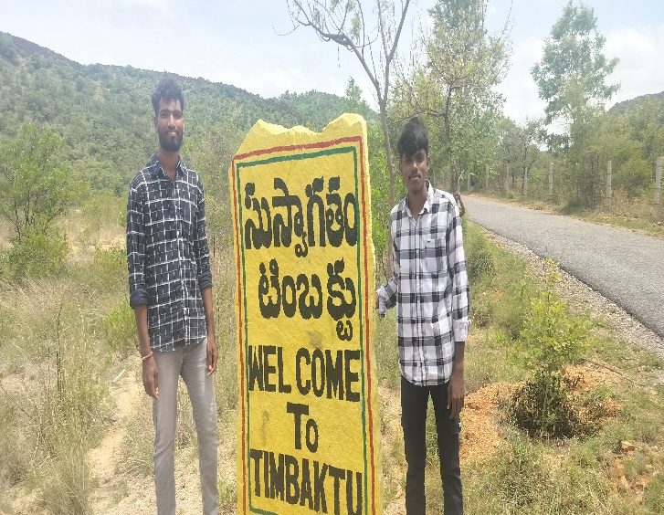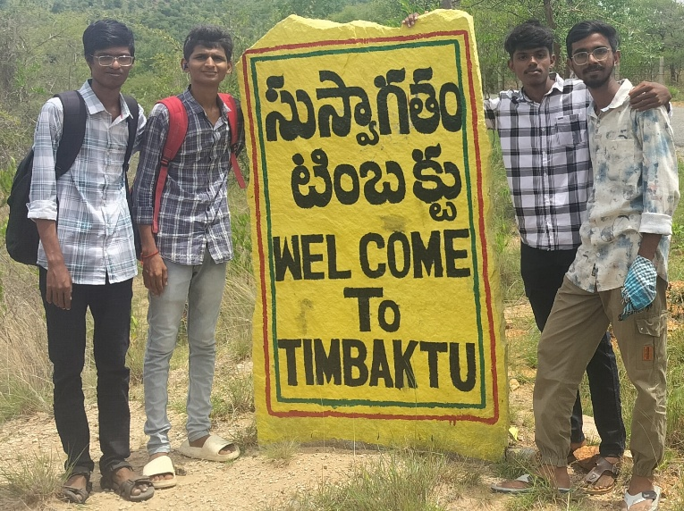 Fig.3.4.a. Entrance to the Timbaktu Collective

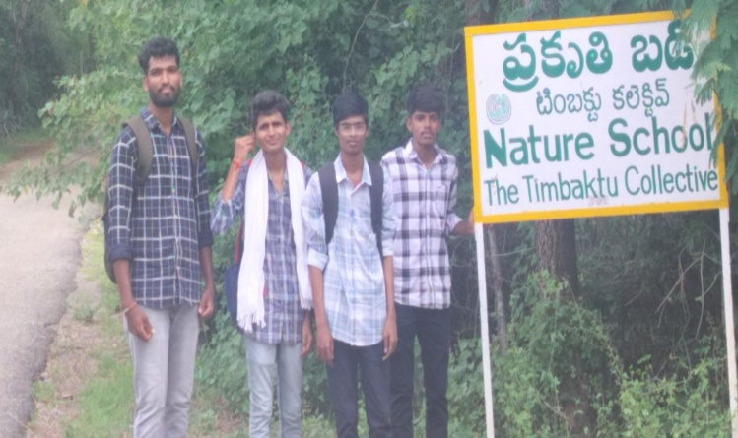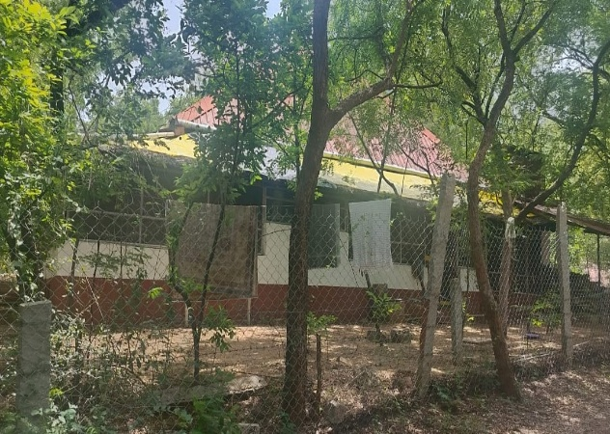 Fig.3.4.b.Children’s school & Lunch section

13

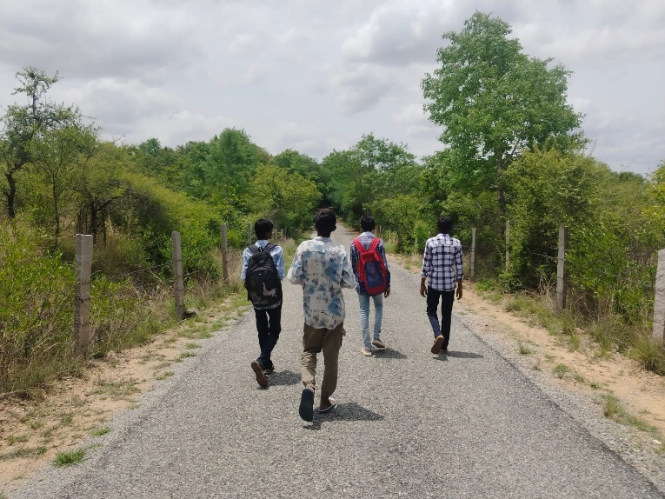 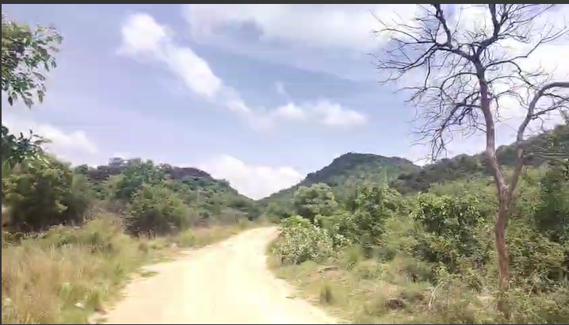 Fig.3.4.c. Kalpavalli area

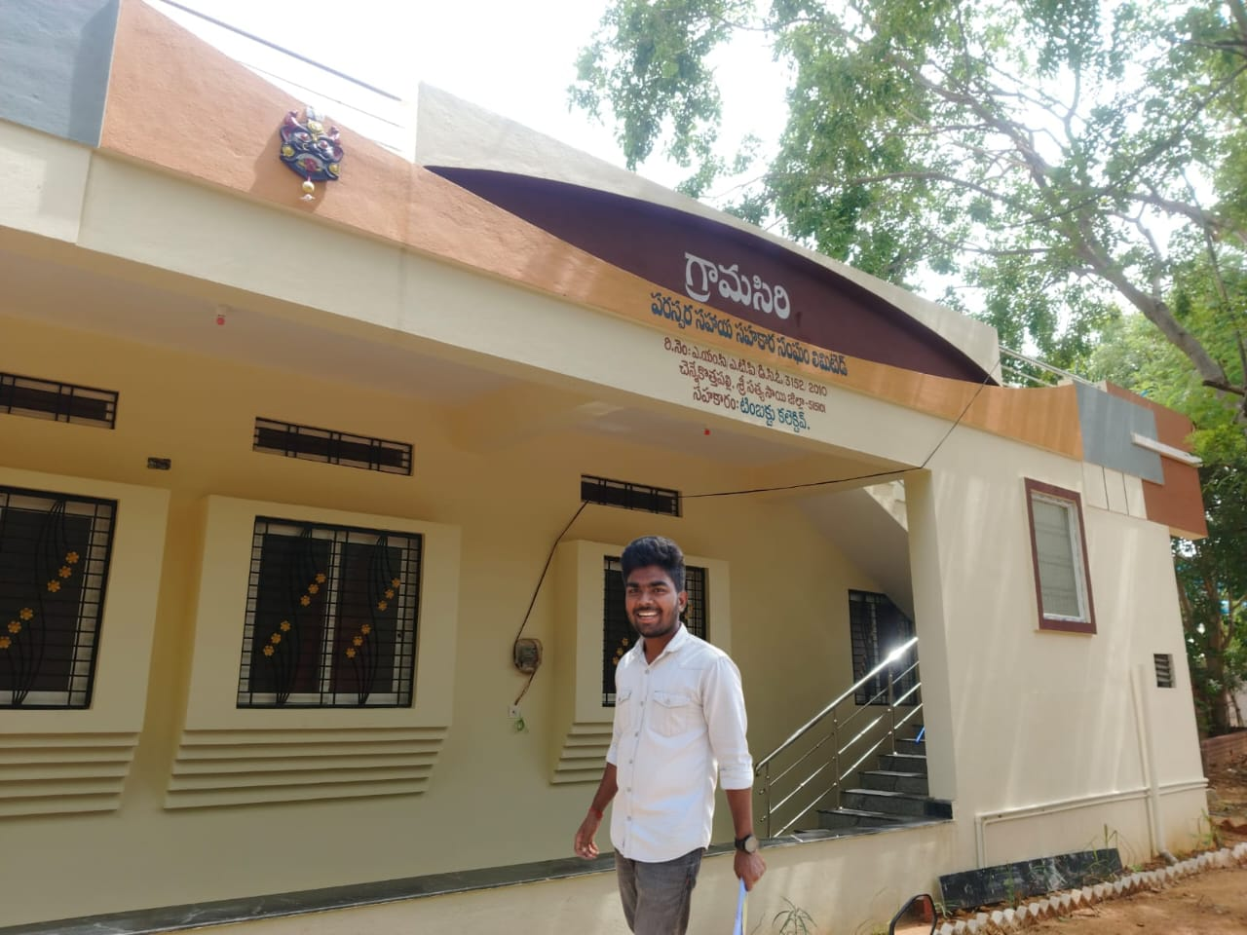 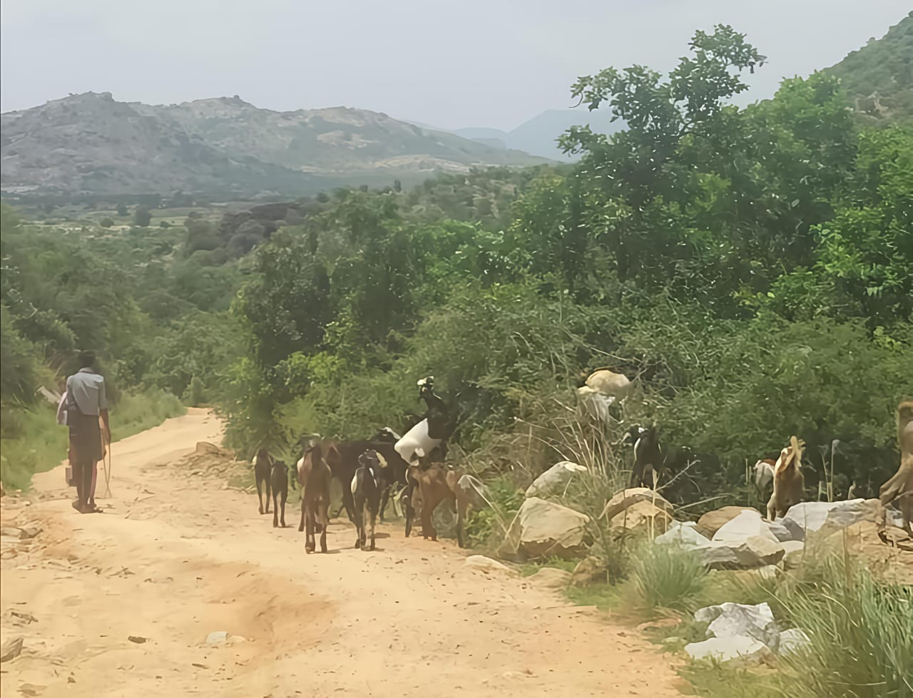

Fig.3.4.d. Gramasiri initiative & it’s office

14

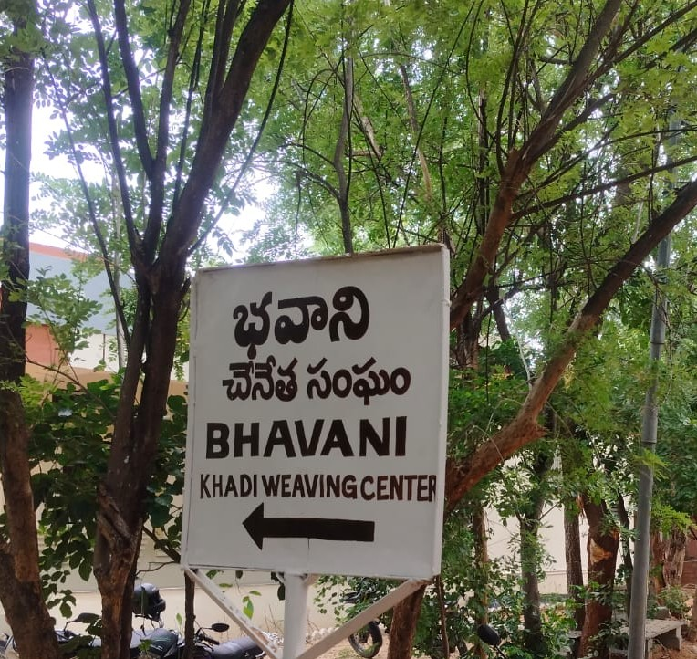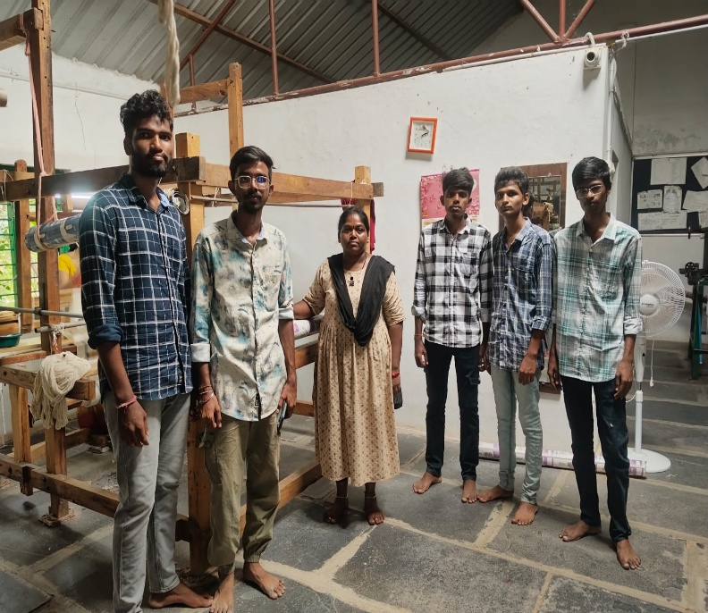

Fig.3.4.e. Bhavani weaving unit

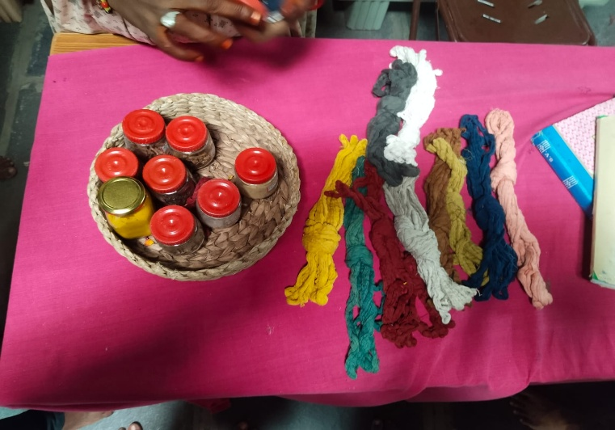 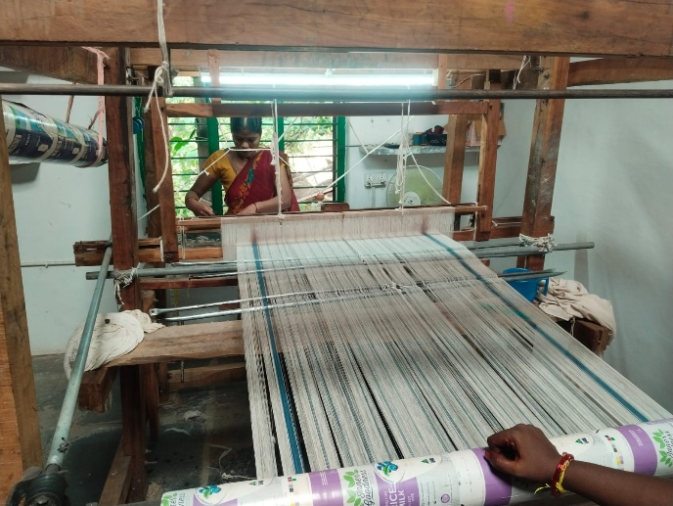

Fig.3.4.f. Handmade threads and hand loom

15

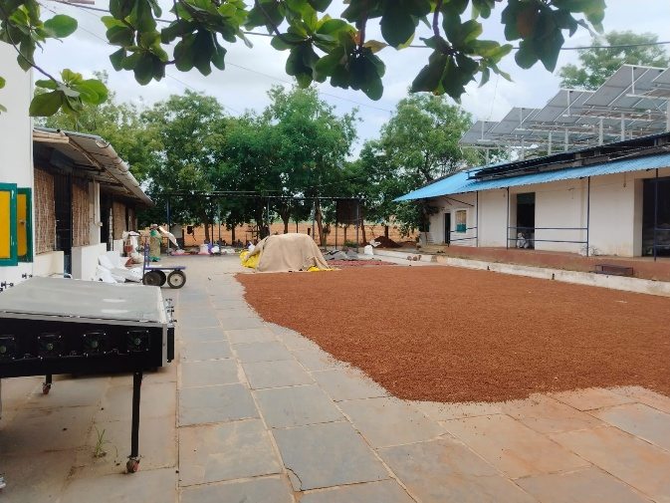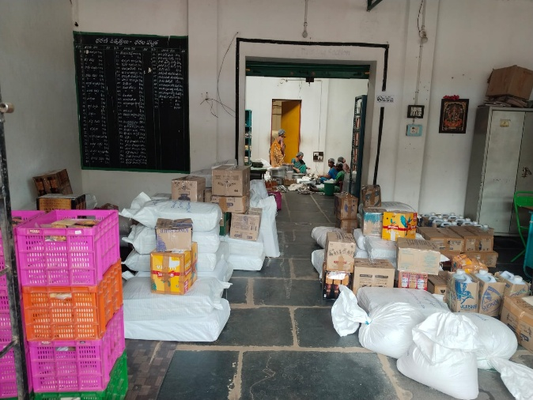

Fig. 3.4.g. Harvesting , storing & packaging of products in Dharani

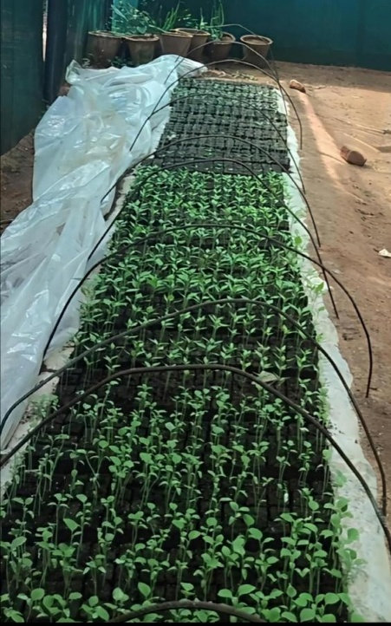 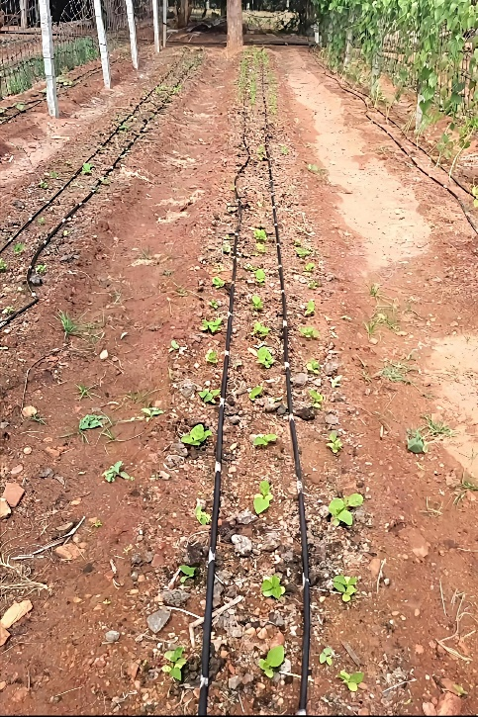 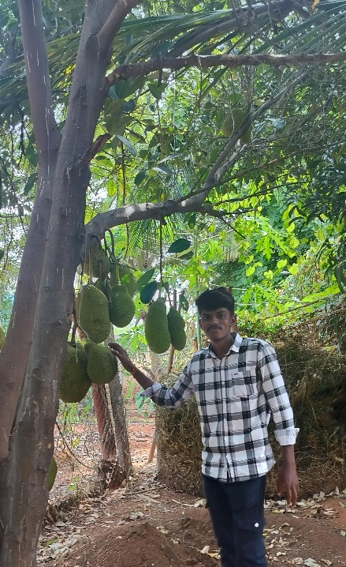

Fig. 3.4.h. Organic Farming initiative

16

**CHAPTER 4**

**BENEFITS**

Our community service journey with the Timbaktu Collective gave us a rare opportunity to work closely with several grassroots initiatives—namely Gramasiri, Dharani, Chiguru, and Kalpavalli—each contributing uniquely to rural sustainability and empowerment. In Gramasiri, we addressed packaging challenges by implementing smart QR-code labeling that enabled traceability and provided essential product information, enhancing both credibility and market reach. In Dharani, we identified post-harvest issues such as poor packaging and dependency on middlemen, and offered solutions like improved branding, batch labeling, and awareness on direct-to-consumer channels, empowering organic farmers to retain more value from their produce. Through Chiguru, we interacted with children from marginalized backgrounds who had limited exposure to modern technology. By introducing them to digital tools and concepts in an engaging way, we helped ignite their curiosity and encouraged digital literacy for their future. In Kalpavalli, a landscape restoration and conservation initiative, we observed environmental challenges such as water scarcity and limited public awareness. We supported the team by documenting practices, spreading awareness about sustainable living, and offering suggestions for eco-education among youth. Across all these projects, we noticed common struggles—lack of exposure, insufficient infrastructure, limited digital literacy, and economic dependency—but also witnessed immense potential for transformation through simple, well-planned interventions.

For us as students, this project was more than just a field assignment—it was a life-changing learning experience. We developed a deeper understanding of rural livelihoods, grassroots entrepreneurship, and community-led sustainability models. Working directly with different communities improved our empathy, communication, and adaptability. We strengthened our leadership and teamwork skills while developing practical solutions like QR tech, branding support, awareness sessions, and documentation. Most importantly, we gained the satisfaction of knowing our work had real, tangible impact. This journey taught us that meaningful change begins with listening, learning, and working together—values we will carry forward both professionally and personally. The CSP experience allowed us to bridge the gap between classroom knowledge and field reality, and helped us grow into more socially responsible and grounded individuals. Overall, this journey helped a lot take a confident step forward in their mission, but also left us with a sense of fulfillment and a clearer understanding of what meaningful community work looks like.

17

**CHAPTER 5**

**CONCLUSIONS AND INFERENCES**

#### 5.1 CONCLUSIONS

In conclusion we can say that Our community service project with the Timbaktu Collective has been an impactful journey of learning, collaboration, and reflection. The project was thoughtfully designed in two phases—remote learning and on-site fieldwork—which together gave us a comprehensive understanding of the organization's grassroots initiatives and their long-term impact on rural communities.

In the first phase, through online research, documentary analysis, and preparation of support materials, we explored Timbaktu's key programs such as Dharani, Chiguru, Swasakthi, and Kalpavalli. These initiatives broadened our understanding of organic farming systems, alternative education, women's empowerment through Self-Help Groups (SHGs), and the importance of ecological conservation. This digital phase laid a strong theoretical foundation and prepared us to engage meaningfully during our field visit.

The fieldwork phase was equally transformative. We interacted directly with community members, observed real-time activities in farms and learning centers, and understood how local leadership, collective action, and sustainability principles are applied on the ground. Walking through reforested lands, sitting in village meetings, and engaging with children and women gave us a powerful sense of how change can begin at the community level. These real-life experiences cannot be substituted by classroom learning alone.

Equally important was the teamwork that evolved throughout the project. We worked together to plan, research, communicate, and adapt to new environments. This strengthened our skills in collaboration, communication, time management, and problem-solving. Each team member brought unique contributions that helped us overcome challenges—whether during remote coordination or while navigating the realities of rural fieldwork.

18

**5.2 INFERENCES**

We can draw many inferences from Community Service Project. We learnt what community service is. It is when individuals or groups of people come together to do work that positively impacts the community without pay. It is different from volunteering since community service can sometimes be a result of coercion or punishment.

From doing the community Service Project we can infer the importance and necessity there is to serve the community. How the people are needy in the outside society and how good it is to help others. We can learn new skills and leadership qualities from doing community service project. We can have good speaking skills too from this project.

We learnt to always give service with an open mind as there is no limit to what you can learn in the process. Learning is essential to our being. The same way food keeps us alive; learning is indispensable as it nourishes our minds. We inferred that helping others can be lot of fun too. The most popular benefit of community service is its impact on the community. However, while giving service, you also connect with other individuals who share your interests. You’ll find yourself talking, bonding, cracking jokes, and enjoying yourself as you work. Besides, getting out of your usual routine to do something different is always a fun experience.

We also got to know that every time you take part in community service, you take home a life

Lesson that will bring you a step closer to realizing your dreams and aspirations in life.

Remember, experience is the best teacher.

19

**5.3 REFERENCES**

1.Timbaktu Collective – Official Website  
 - <https://timbaktu.org>

The official site provides in-depth details about their history, programs.

2.India Development Review (IDR)  
 - <https://idronline.org>  
 Search for articles or case studies about grassroots organizations like

Timbaktu.

3.Global Giving – Timbaktu Collective Profile  
 - <https://www.globalgiving.org/donate/13794/the-timbaktucollective/>

Offers external validation of the NGO, with donor feedback and

Important updates.

4.Dharani Farming & Marketing Cooperative Ltd.  
 - <https://dharani-farmers.org>  
 Dedicated site for the organic farming wing of Timbaktu, describing

farmer networks, organic practices, and cooperative structure.

5.Instagram & Social Media *(for updates and product info)*

* Instagram: <https://www.instagram.com/timbaktu.collective/>
* Facebook: <https://www.facebook.com/TimbaktuCollective/>
* Regular updates on field activities, exhibitions, and product stalls.

20